**TASK 1: New IMPLEMENTATION OF TECHNOLOGY SOLUTION**

Work created by Aaron George for C768 Task 1

**TASK 1: New IMPLEMENTATION OF TECHNOLOGY SOLUTION**

Created by Aaron George for C768: Technical Communication

**C768 Technical Communication**

Student Name: Aaron George

Student ID: 001384512

Degree Program: Computer Science

Student Mentor Name: Kellie Moore

**Table of Contents**

Cover Page 1

Table of Contents 2

A. Internal Communication Artifact 3

B. Fact Sheet Artifact 4

C. Writing Process for Artifacts 5

i. The Overview of Audiences

ii. The Planning of Artifact One

iii. The Drafting of Artifacts

iv. The Planning of Artifact Two

v. Revision of Artifact One

vi. Revision of Artifact Two

D. Audience Analysis of Each Artifact 6

**Topic:** A need for an upgrade to the network Cabling to further the company’s growth.

**Date: 11/12/20**

**From:** Aaron George (AaronGeorge20@Boogle.com)

**To:** SabrinaRobinson@Boogle.com

Dear Ms. Sabrina and Executive Staff:

Mr. Kyle has given my team the opportunity to work and manage the network for better improving the efficiency of our corporation. Our job duties require us to ensure that our network and all communication resources are always operatable to every department in the company 24/7. He has brought to my attention that there is a strong desire to transition into more profitable markets while reducing unnecessary costs and increasing productivity among our workers. Technology-based solutions are always on the raise throughout our demographic of consumers and innovation key. In order to persevere in this ever-changing economic environment, we must develop brand new technology equipment and implement them on a professional business level. The main reason for this desire for advancement is mainly dependent on ensuring that we assure the same level of quality of service we have provided to our users in the past. Mr. Kyle has suggested that a need for an upgrade to the network cabling is important to further the company’s growth.

One of our organization’s current network main issue is that we still use a T1 copper cable, which can only handle a maximum bandwidth rate of 1.544 Mbps, which has been used for over 15 years. When this network was first installed it was sufficient for the network capabilities at the time. I would also like to note that our T1 cable is very important on our current communications infrastructure among our technology including, phone, fax, computer, and network. As we grow in users, we will experience major slowdown in response times and calls, and it can affect the proficiency of business among the employees. Switching to a fiber optic network topology will fix the solution making sure that never happens. After thorough research, consideration, and planning with the intelligent members of the IT department we found a concrete solution for the problem which not only will allow us to keep up-times during operation, cut cost, and still provide excellent work proficiency.

The solution begins with breaking our current contract with the ISP provider Comcast and switching over to Verizon. We identified that there is are 3 packages that can achieve what we are looking for. These plans all include a flat $11,000 installation fee and a monthly fee. These service fees plus a monthly fee of $120, $350, or $525 are all depending on the plan chosen.

Ultimately, this will ensure that we can handle an increase number of traffic from calls with the improved VOIP system. Per Mr. Kyle’s request, our department supervisors have made a fact sheet that includes the proper planning and diagramming needed to make this a smooth transition without any complications. If approved, every department has a plan in motion to select the needed staff members and outline the time frame required to update our network’s firewalls and protocols. The procedure will require 60 to 90 days of adjustment time with the last day being dependent on the ISP, Verizon. I am honored by your combined efforts for an improved infrastructure and we look forward to helping Bogle continue to grow and thrive.

Yours truly,

Aaron George

Operations of a network topology

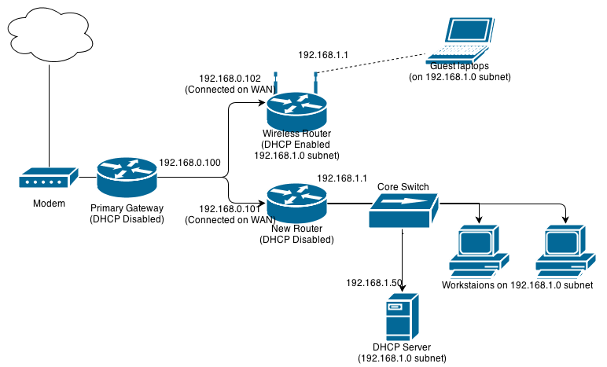

**What is a Fiber Network?**

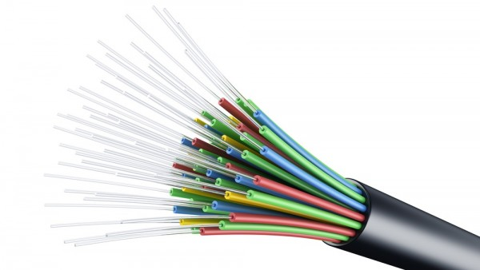

Fiber-Optic Network cables are used to transmit pluses of light through cable enhancing its speed making it more sufficient than the older copper cable, making network speeds much faster than ever.

**Why a Fiber-Optic network should be implemented in the company**



We at Bogle take pride in our organization and our staff. We strive to provide our consumers with the upmost satisfaction. Our company takes pride in our network and room for improvements is all ways need which we strive to achieve. We hope to always provide the best services any person could ask for.

**Network Upgrade**

“In fiber-optic communications, where they permit transmission over longer distances and at higher bandwidths (data transfer rates) than electrical cables. Fibers are used instead of metal wires because signals travel along them with less loss

"*Source: Optical fiber https://en.wikipedia.org/wiki/Optical_fiber*

Phase 1: The executive management will select the service package they are satisfied with and start the drafting process. Network service supervisor will compile array of multiple static IP addresses and gateways (shown above).

Phase 2: Reliable supervisors from the required departments (HR, Security, Networking, etc.) will assign employees to begin transition to each department.

Phase 3: ISP will start work September 4th and install lightbox and new fiber optic switches in the network area. Early network testing will also occur during this procedure. Once testing is finished, we will create an intranet environment using the fiber-network and present it for sign-off. During this period the front service desk will also receive aa newly reformed training manual and spend 4 hours learning troubleshooting training scenarios.

Phase 4: After hours of business, the network team will begin full integration into the fiber-optic structure. This will cause an approximation of 6 hours of down time on our severs.

Phase 5: During the 2 weeks following phase 4 IT department will continue to oversee the network, making sure everything is stable. After this time period is complete, all operations will return to normal

**Summary of Requirements in Different Phases**

**The Process Description for Writing Artifacts (Planning, Drafting, Revision & Editing)**

**A Summary of Audiences**

All information related to the specific artifacts will be distributed with either (1) executive leadership in charge of the organization or (2) relevant teams with that department. Executive leadership consists of important, key stakeholders including the CFO, CIO, and upper management. This also includes any working able managers that are included in the security and networking division. They should be alerted of any complications, achievements, milestones, or necessary alterations. Furthermore, the CIO will be branded as the projects head sponsor and will provide the awarding for any milestone completed. Multi-functional groups will be all necessary members of the IT department who will be executing and supplying feedback for the fulfillment of the network upgrade. This team will be composed of handpicked members of the following 3 sub-IT groups: HR, Security, and Network. Their knowledge and feedback will be crucial of the successful management and execution of a fiber optic topology. I established this diverse range of audiences so I could explain the many unique types of people found in a company.

**The Writing Processes Examination for Previously Explained Artifacts**

* **Planning of Artifact One (important Internal Communication)** involves carefully studying the reader’s purposes, needs, and writing situations. These elements play and key role and will also help aid with collecting the needed information and arranging the data to appeal to a communicative atmosphere that will please the required stakeholders. I established this email to display that not every stakeholder present will have the technical information needed to comprehend the necessary procedures for relocating the network. To better suit their demands, I created this paper to fulfill their desires rather than focus solely on technical language. Furthermore, I presumed it was crucial to create a paper based on a proposal from an executive member. I strongly felt that this was the best option to seek approval from the audience.
* **The Drafting of Artifacts** was centered on taking the situation I developed in the planning process and condensing it to fit my reader’s requirements. The drafting phase came out to be an important step for me because it made me come to the realization that the initial first drafts were missing vital information that I would consider too vital for an executive team. This made me consider condensing the document while also inserting more information like the cost and company broad benefit.
* **The Planning of Artifact Two (Fact Sheet)** is set in motion after I chose the purpose of the fact sheet. I recognized that I would be tackling 3 sub-departments and needed to set a standard of knowledge level. I wanted to compose a paper that clearly stated why we are doing this and how to get it done. This required me arranging the document to show that clarity. The fact sheet was designed as well to notify and instructor all factions.
* **The Revision and Editing of Artifact One (Important Internal Communication)** is based on content and arrangement. I wanted to reduce the material to fit in a compact email that supplied enough information that was significant to the readers. The document had to also be organized in a way that gave the readers a clear and easy choice to make.
* **The Revision and Editing of Artifact Two (Fact Sheet)** had very different objectives in mind. The main emphasis of this paper was mainly on language and graphic aids. I had to lessen the reach of my description to make it easier to explain the required networking phrases without using an abundance of computer jargon. I also wanted to add a graphic aid that presented a top-level view of the alter but did not want it to take up the entire document. I thought this was quite important because not all consumers involved required to have the network layout, but it was a very critical aspect of the network upgrade.

**The Audience Analysis of Each and Every Artifact**

**Artifact 1: The Email to Executives**

Artifact 1 mainly addresses the first audience which is composed of the head CEO, Mr. Kyle, and his executive party. Mr. Kyle is knowledgeable in finance and business and has worked doing publishing business most of his existence. His information of IT is somewhat limited. This audience is eccentric, positive, and passionate about the abundant growth of their company. They will respond well to any propositions brought toward them that can further grow the company through means of IT.

* **Crucial Subject Matter Knowledge -** His technical background is not the strongest, and his understanding of how networks operate is not the best. My document focuses primarily made tailored to him by outlining the features of what a network is and why it needs to be improved. I purposely try to limit the amount of technical details as I possibly can to not make his understanding complex.
* **His Primary Position in the Organization –** The CEO is without a doubt a superior position in the company and is solely based on his decision if the proposal is brought to fruition. The document is designed for level of understanding and inspire him to go forward with a decision. Persuading the readers is a very important process.
* **Some Personal Attitudes –** I noticed that the executive team is open to the idea of change and expansion. I felt keeping a positive feeling throughout the email will appeal to these emotions and encourage them to become keen to act.
* **Different Reading Styles –** Given that my main objective of this document is to convince readers to act I wrote with the main intention that readers will better from the entire document. I want to give the CEO a consistent scope of the process and make sure all reads will understand that as a positive change.
* **The Many Types of Readers –** The primary reader is the CEO and the executives are the secondary readers. Because Mr. Kyle is the one to make the final decision, I wrote the document to fit his comprehension and try to avoid haughty technical language.

**Artifact 2: The Fact Sheet for Functional Peers and Managers**

Artifact 2, a fact sheet that was created with the entire IT department in mind who is involved with the operation. I designed the document to show partnership from the working managers to fit all the audience.

* **Subject Knowledge –** With the wide scope of sub level IT groups that are cooperating with the Networking phase I created the document to focus on basic level information about the topic. These individuals are using the network every single day for their differing business procedures, and I can classify the bulk of the group as semi-experts.
* **Positions in the Company –** The Manger hold the most reliability and dependability in the group. Yet, the document is geared toward peers so that fellow members of the team can see the document as a reference for communication skills among coworkers.
* **Personal Attitudes –** the fact sheet is catered to all groups and sub-groups in the organization. It benefits all parties involved. Many personalities were considered when comprising it.
* **Reading Styles -** The fact sheet is addressed to suggest that the readers (audience) are secondary level knowledge readers in nature. The main purpose is to provide the proper information to inform them of their job .
* **Types of Readers -** The document was made to encourage readers to check for specific sections of information. The left side section should be understood by all consumers (readers) while the terms are specific to each group. Catering to both audiences.